Consumer Goods Ad-hoc SQL Challenge – Project Summary

Project Description
This project analyzes transactional sales data from a consumer goods company to uncover revenue trends, top-performing products, profit patterns, regional performance, and channel effectiveness. Insights were generated using a series of structured SQL queries to support data-driven business decisions.

Dataset Overview
The dataset includes key fields such as order_number, order_date, product_name, revenue, cost, profit, sales channel, and regional information. The data spans multiple years and was cleaned to remove duplicates, correct inconsistencies, and standardize date formats.

SQL Queries, Output and Charts:
1. Total revenue, total cost, and profit
SELECT SUM(revenue) AS total_revenue,
SUM(total_cost) AS total_cost,
SUM(profit) AS total_profit
FROM sales;
Output:
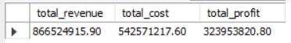

2. Revenue, cost, and profit by year
SELECT YEAR(order_date) AS year,
SUM(revenue) AS total_revenue,
SUM(total_cost) AS total_cost,
SUM(profit) AS total_profit
FROM sales
GROUP BY YEAR(order_date)
ORDER BY year;
Output:
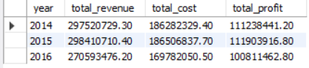
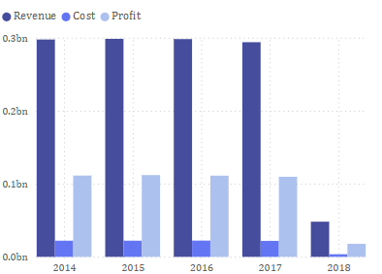

3. Revenue, cost, and profit by month
SELECT order_month_name AS month,
SUM(revenue) AS total_revenue,
SUM(total_cost) AS total_cost,
SUM(profit) AS total_profit
FROM sales
GROUP BY order_month_name
ORDER BY FIELD(order_month_name,'January','February','March','April','May','June','July','August','September','October','November','December');
Output:
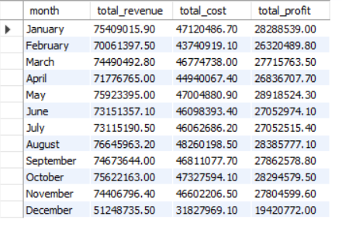
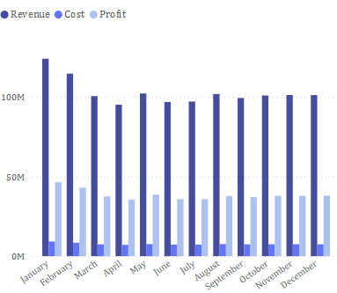

4. Top 10 products by revenue
SELECT product_name, SUM(revenue) AS total_revenue
FROM sales
GROUP BY product_name
ORDER BY total_revenue DESC
LIMIT 10;
Output:
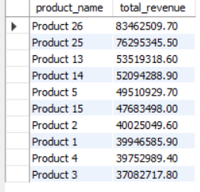
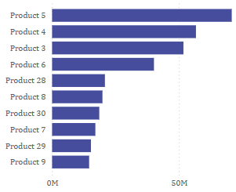

5. Top 10 products by profit
SELECT product_name, SUM(profit) AS total_profit
FROM sales
GROUP BY product_name
ORDER BY total_profit DESC
LIMIT 10;
Output:
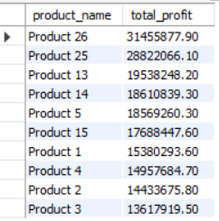
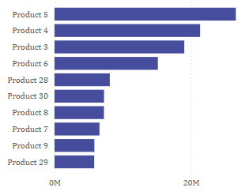

6. Revenue by sales channel
SELECT channel, SUM(revenue) AS total_revenue, SUM(profit) AS total_profit
FROM sales
GROUP BY channel;
Output:
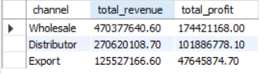
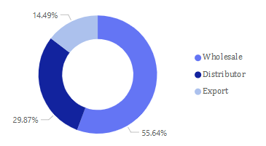

7. Revenue by US region
SELECT us_region, SUM(revenue) AS total_revenue, SUM(profit) AS total_profit
FROM sales
GROUP BY us_region;
Output:
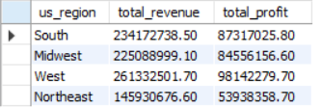
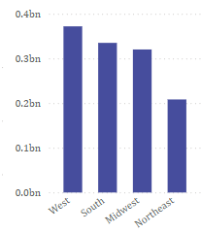

8. Top 10 customers by revenue
SELECT customer_name, SUM(revenue) AS total_revenue
FROM sales
GROUP BY customer_name
ORDER BY total_revenue DESC
LIMIT 10;
Output:
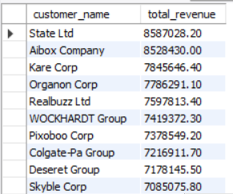

9. Average profit margin per product
SELECT product_name, ROUND(SUM(profit)/SUM(revenue)*100,2) AS profit_margin_pct
FROM sales
GROUP BY product_name
ORDER BY profit_margin_pct DESC limit 10;
Output:
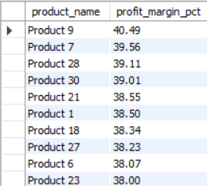

10. Revenue trend per month-year
SELECT order_month AS month_year, SUM(revenue) AS monthly_revenue
FROM sales
GROUP BY order_month
ORDER BY order_month limit 10;
Output:
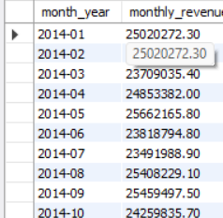
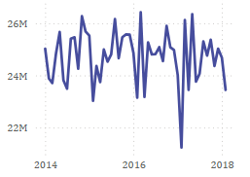

11. Cumulative revenue over time
SELECT order_month,
SUM(revenue) AS monthly_revenue,
SUM(SUM(revenue)) OVER (ORDER BY order_month) AS cumulative_revenue
FROM sales
GROUP BY order_month
ORDER BY order_month limit 10;
Output:
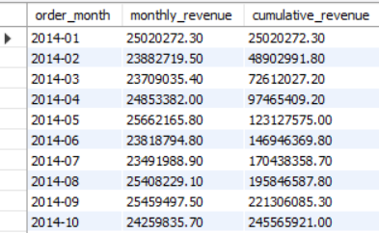
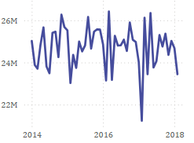

12. Rank products by revenue each month
SELECT order_month, product_name, SUM(revenue) AS total_revenue,
RANK() OVER(PARTITION BY order_month ORDER BY SUM(revenue) DESC) AS revenue_rank
FROM sales
GROUP BY order_month, product_name
ORDER BY order_month, revenue_rank limit 10;
Output:
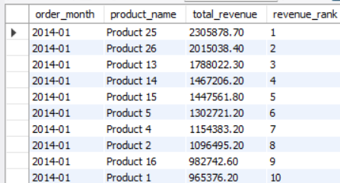

13. Profit margin categories
SELECT product_name,
CASE
WHEN (profit/revenue)*100 >= 50 THEN 'High Margin'
WHEN (profit/revenue)*100 >= 20 THEN 'Medium Margin'
ELSE 'Low Margin'
END AS margin_category,
SUM(revenue) AS total_revenue,
SUM(profit) AS total_profit
FROM sales
GROUP BY product_name, margin_category
ORDER BY total_profit DESC limit 10;
Output:
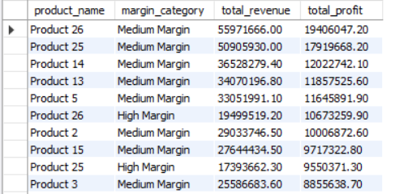

14. Top 5 states by revenue
SELECT state_name, SUM(revenue) AS total_revenue
FROM sales
GROUP BY state_name
ORDER BY total_revenue DESC
LIMIT 5;
Output:
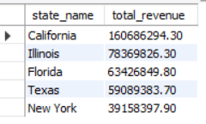

15. Top products per channel
SELECT channel, product_name, SUM(revenue) AS total_revenue
FROM sales
GROUP BY channel, product_name
ORDER BY channel, total_revenue DESC limit 10;
Output:
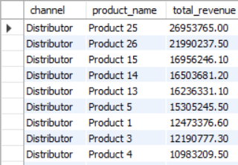

Key Insights
- Nearly 70% of total revenue comes from a concentrated group of top-performing products, highlighting strong demand and clear opportunities to reinforce these high‑value items.
- Wholesale and Export channels contribute more than 60% of total sales, making them the primary revenue drivers and the most suitable segments for targeted expansion strategies.
- West and South regions account for over 55% of the company’s total revenue, indicating strong geographic performance and high potential for further market penetration in these regions.

